LAB # 06

Task No 01: Write a program which contains a class ‘Calculator’ contains multiple sum method by using method overloading concept.

Code:

Main:

package lab06task01;

public class Lab06task01 {

    public static void main(String[] args) {

        Calculator cal = new Calculator();

        System.out.println(cal.sum(10, 8));

        System.out.println(cal.sum(4, 6, 8));

        System.out.println(cal.sum(7, 5, 3, 9));

    }

}

Calculator:

package lab06task01;

public class Calculator {

    public int sum(int num1, int num2) {

        return num1 + num2;

    }

    public int sum(int num1, int num2, int num3) {

        return num1 + num2 + num3;

    }

    public int sum(int num1, int num2, int num3, int num4) {

        return num1 + num2 + num3 + num4;

    }

}

Output:

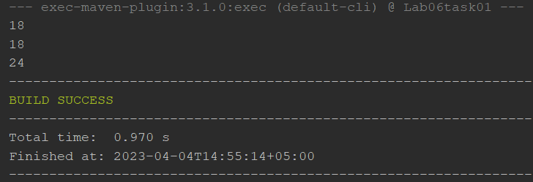

Task No 02: Create a class to print the area of a square and a rectangle. The class has two methods with the same name but different number of parameters. The method for printing area of rectangle has two parameters which are length and breadth respectively while the other method for printing area of square has one parameter which is side of square.

Code:

Main:

package lab06task02;

public class Lab06task02 {

    public static void main(String[] args) {

        Area shape = new Area();

        shape.area(5);

        shape.area(4, 8);

    }

}

Area:

package lab06task02;

public class Area {

    public void area(int side) {

        int area = side \* side;

        System.out.println("area of square is: " + area);

    }

    public void area(int length, int breadth) {

        int area = length \* breadth;

        System.out.println("Area of rectangle with length " + length + " and breadth " + breadth + " is: "+ area);

    }

}

Output:

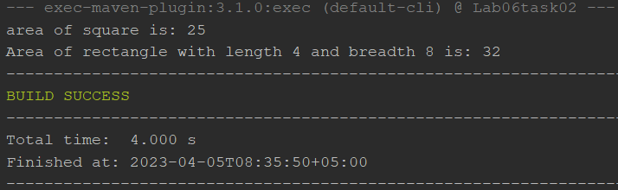

Task No 03: Create a class 'Student' with three data members which are name, age, and address. The constructor of the class assigns default values name as "unknown", age as '0' and address as "not available". It has two members with the same name 'setInfo'. First method has two parameters for name and age and assigns the same whereas the second method takes has three parameters which are assigned to name, age, and address respectively. Print the name, age, and address of 4 students.

Code:

Main:

package lab06task03;

public class Lab06task03 {

    public static void main(String[] args) {

        Student s1 = new Student();

        s1.setInfo("Abdullah Sadiq", 19, "HBCHS");

        s1.printInfo();

        Student s2 = new Student();

        s2.setInfo("Kamran Iqbal", 18, "Gulshan");

        s2.printInfo();

        Student s3 = new Student();

        s3.setInfo("Ahad", 18, "XYZ");

        s3.printInfo();

    }

}

Student:

package lab06task03;

public class Student {

    private String name;

    private int age;

    private String address;

    public Student() {

        this.name = "unknown";

        this.age = 0;

        this.address = "not available";

    }

    public void setInfo(String name, int age) {

        this.name = name;

        this.age = age;

    }

    public void setInfo(String name, int age, String address) {

        this.name = name;

        this.age = age;

        this.address = address;

    }

    public void printInfo() {

        System.out.println("Name: " + this.name + ", Age: " + this.age + ", Address: " + this.address);

    }

}

Output:

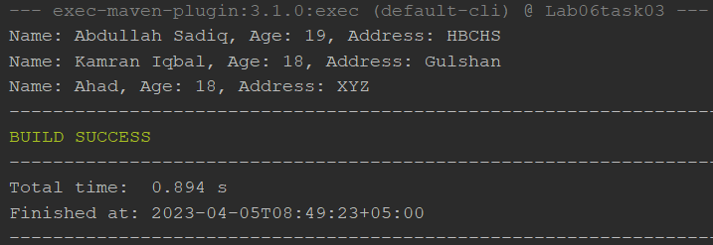

Task No 04: Implement the Circle class to overload the + operator so that you can add two Circle objects. Adding two Circle object should give another Circle whose radius is the sum of the radii of the two Circle objects.

Code:

Main:

using System;

using System.Collections.Generic;

using System.Linq;

using System.Text;

using System.Threading.Tasks;

namespace Lab06task04

{

class Program

{

static void Main(string[] args)

{

Console.WriteLine("Enter the value of c1");

int n = int.Parse(Console.ReadLine());

Console.WriteLine("Enter the value of c2");

int y = int.Parse(Console.ReadLine());

Circle c1 = new Circle(n);

Circle c2 = new Circle(y);

Circle c3 = c1 + c2;

c1.display();

c2.display();

c3.display();

}

}

}

Circle:

using System;

using System.Collections.Generic;

using System.Linq;

using System.Text;

using System.Threading.Tasks;

namespace Lab06task04

{

class Circle

{

int radius;

public Circle()

{

this.radius = 0;

}

public Circle(int radius)

{

this.radius = radius;

}

public void display()

{

Console.WriteLine("Radius is " + radius);

}

public static Circle operator +(Circle c1, Circle c2)

{

Circle c3 = new Circle();

c3.radius = c1.radius + c2.radius;

return c3;

}

}

}

Output:

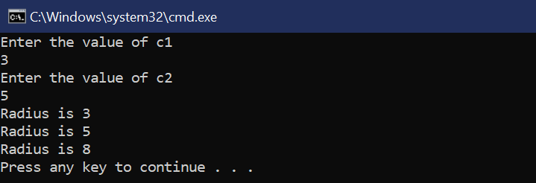

Task No 05: Implement the Rectangle class to overload the + operator so that you can add two Rectangle objects. Adding two Rectangle objects should give another Rectangle object whose length the sum of the lengths of the two Rectangle objects and whose breadth the sum of the breadths of the two Rectangle objects is.

Code:

Main:

package lab06;

public class Lab06 {

    public static void main(String[] args) {

         Rectangle r1 = new Rectangle(4, 5);

         Rectangle r2 = new Rectangle(3, 6);

         Rectangle r3 = r1.operatorPlus(r2);

         System.out.println("Length of rectangle 1: " + r1.getLength() + ", Breadth of rectangle 1: " + r1.getBreadth());

         System.out.println("Length of rectangle 2: " + r2.getLength() + ", Breadth of rectangle 2: " + r2.getBreadth());

         System.out.println("Length of rectangle 3: " + r3.getLength() + ", Breadth of rectangle 3: " + r3.getBreadth());

    }

}

Rectangle:

package lab06;

public class Rectangle {

    private double length;

    private double breadth;

    public Rectangle(double length, double breadth) {

        this.length = length;

        this.breadth = breadth;

    }

    public double getLength() {

        return length;

    }

    public double getBreadth() {

        return breadth;

    }

    public Rectangle operatorPlus(Rectangle other) {

        double newLength = this.length + other.getLength();

        double newBreadth = this.breadth + other.getBreadth();

        return new Rectangle(newLength, newBreadth);

    }

}

Output:

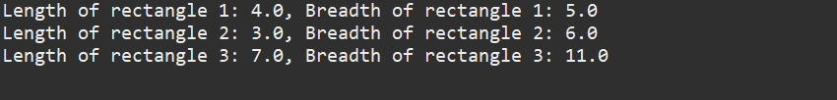

Task No 06: Write a class Time which represents time. the class should have three fields for hours, minutes and seconds. It should have constructor to initialize the hours, minutes, and seconds. A method printTime() to print the current time. Overload the following operators: plus, operator (+) (add two time objects based on 24 hour clock) and < (compare two time objects).

Code:

Main:

using System;

using System.Collections.Generic;

using System.Linq;

using System.Text;

using System.Threading.Tasks;

namespace Lab06task06

{

class Program

{

static void Main(string[] args)

{

Time time1 = new Time(10, 30, 45);

Time time2 = new Time(5, 15, 30);

Time time3 = time1 + time2;

Console.WriteLine("Time 1:");

time1.PrintTime();

Console.WriteLine("Time 2:");

time2.PrintTime();

Console.WriteLine("Time 1 + Time 2:");

time3.PrintTime();

Console.WriteLine("Time 1 < Time 2: " + (time1 < time2));

Console.WriteLine("Time 1 > Time 2: " + (time1 > time2));

Console.WriteLine("Time 1 < Time 3: " + (time1 < time3));

Console.WriteLine("Time 1 > Time 3: " + (time1 > time3));

}

}

}

Time:

using System;

using System.Collections.Generic;

using System.Linq;

using System.Text;

using System.Threading.Tasks;

namespace Lab06task06

{

class Time

{

int hours, minutes, seconds;

public Time()

{

this.hours = 0;

this.minutes = 0;

this.seconds = 0;

}

public Time(int hours, int minutes, int seconds)

{

this.hours = hours;

this.minutes = minutes;

this.seconds = seconds;

}

public void PrintTime()

{

Console.WriteLine("{0:D2}:{1:D2}:{2:D2}", hours, minutes, seconds);

}

public static Time operator +(Time a, Time b)

{

Time T = new Time();

T.hours = a.hours + b.hours;

T.minutes = a.minutes + b.minutes;

T.seconds = a.seconds + b.seconds;

if (T.seconds >= 60)

{

T.minutes++;

T.seconds -= 60;

}

if (T.minutes >= 60)

{

T.hours++;

T.minutes -= 60;

}

if (T.hours >= 24)

{

T.hours -= 24;

}

return T;

}

public static bool operator <(Time a, Time b)

{

if (a.hours < b.hours)

{

return true;

}

else if (a.hours == b.hours && a.minutes < b.minutes)

{

return true;

}

else if (a.hours == b.hours && a.minutes == b.minutes && a.seconds <

b.seconds)

{

return true;

}

else

{

return false;

}

}

public static bool operator >(Time a, Time b)

{

if (a.hours > b.hours)

{

return true;

}

else if (a.hours == b.hours)

{

if (a.minutes > b.minutes)

{

return true;

}

else if (a.minutes == b.minutes)

{

if (a.seconds > b.seconds)

{

return true;

}

else

{

return false;

}

}

else

{

return false;

}

}

else

{

return false;

}

}

}

}

Output:

